**Practical No. 9**

**App Development using Cloud Computing**

**Aim: Develop application for Microsoft Azure**

# Step 1:

To develop an application for Windows Azure on Visual Studio 2019, install the Visual Studio 2019.

# Step2:

* Open Visual Studio 2019
* Click on create new project

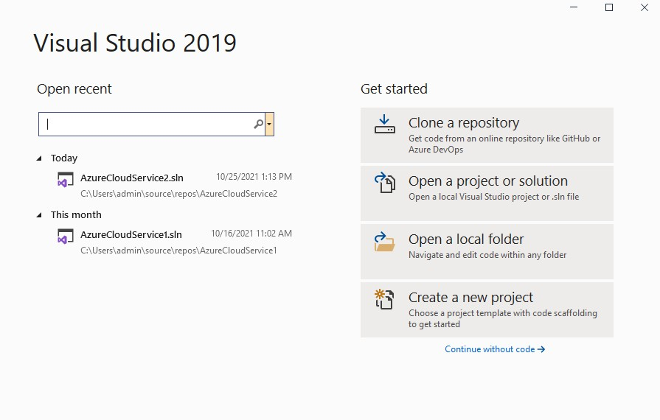

* + After clicking on Create new project, a **New Project Window** will open

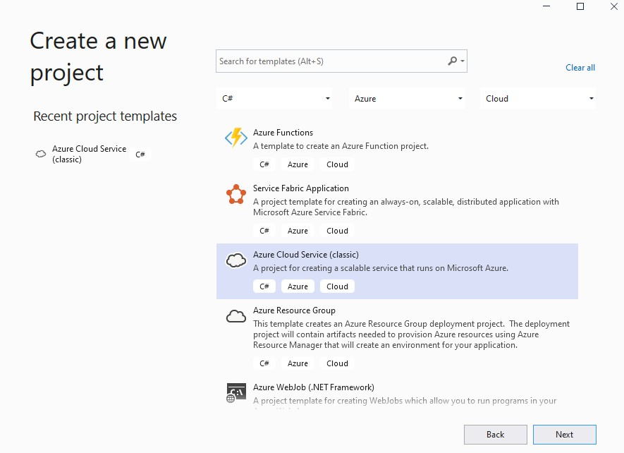

* + In above window, choose **Language** as C#, **Platform** as Azure, **Project** as Cloud
  + Then select Azure Cloud Service(classic) option

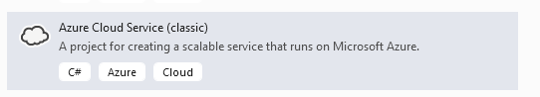

* + Click Next
  + Configure project window will appear.

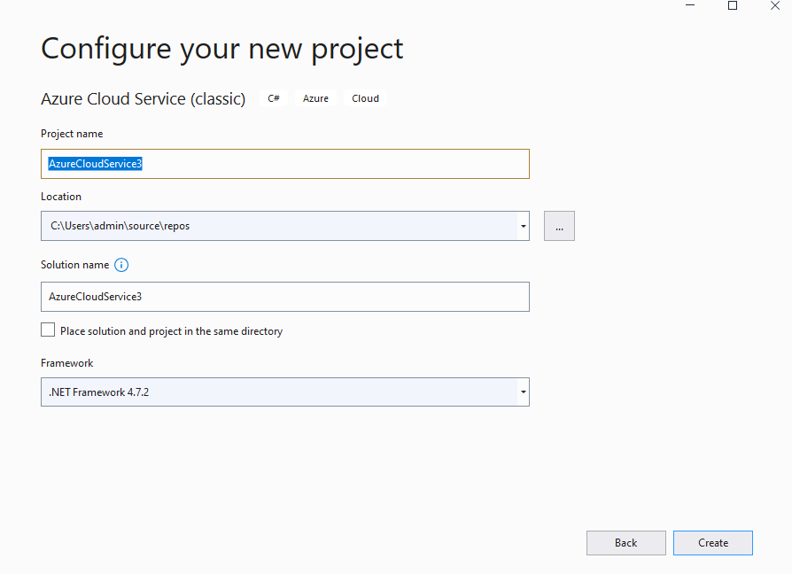

* + Enter Project name(AzureCloudService3), then click on Create button.
  + New Microsoft Azure Cloud Service(Classic) window will appear as below. Select Visual C# -> ASP.net Web Role.

• 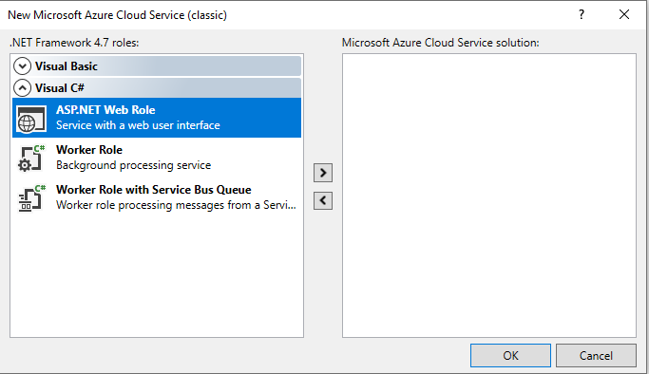

* + Click on **> button for add role to solution.**
  + Below window will appear.

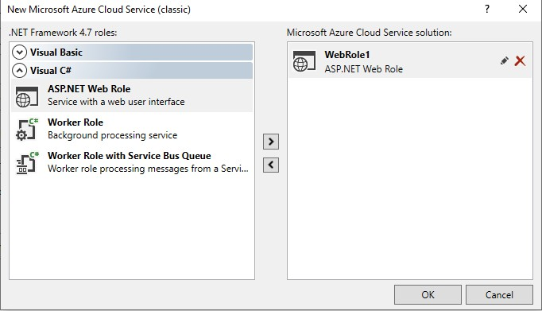

* + Click on OK button.
  + Below window will appear.

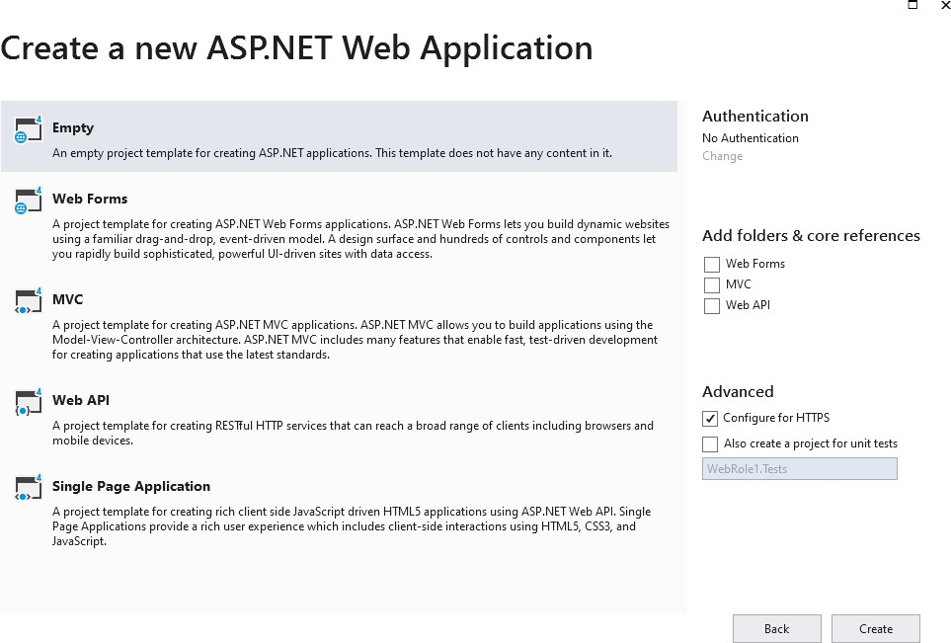

* + Select Empty Option for creating empty project template and then click on Create Button. Below window will appear.

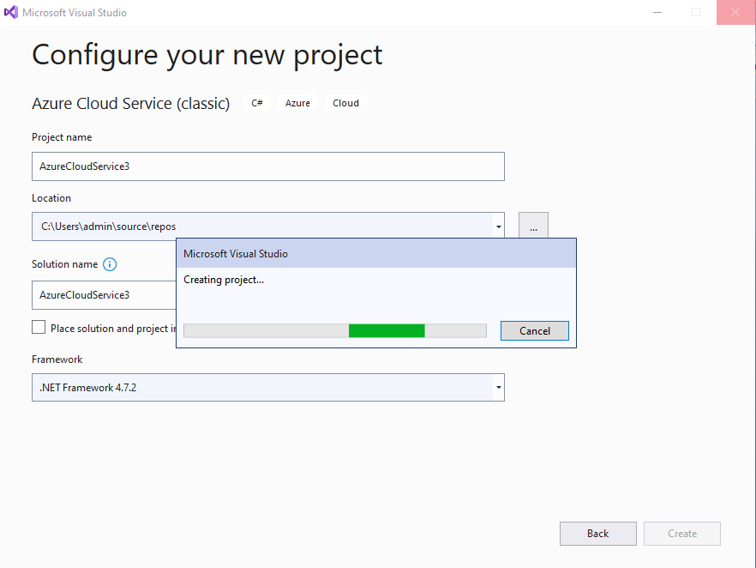

Right Click on WebRole1 in Solution Explorer Window.

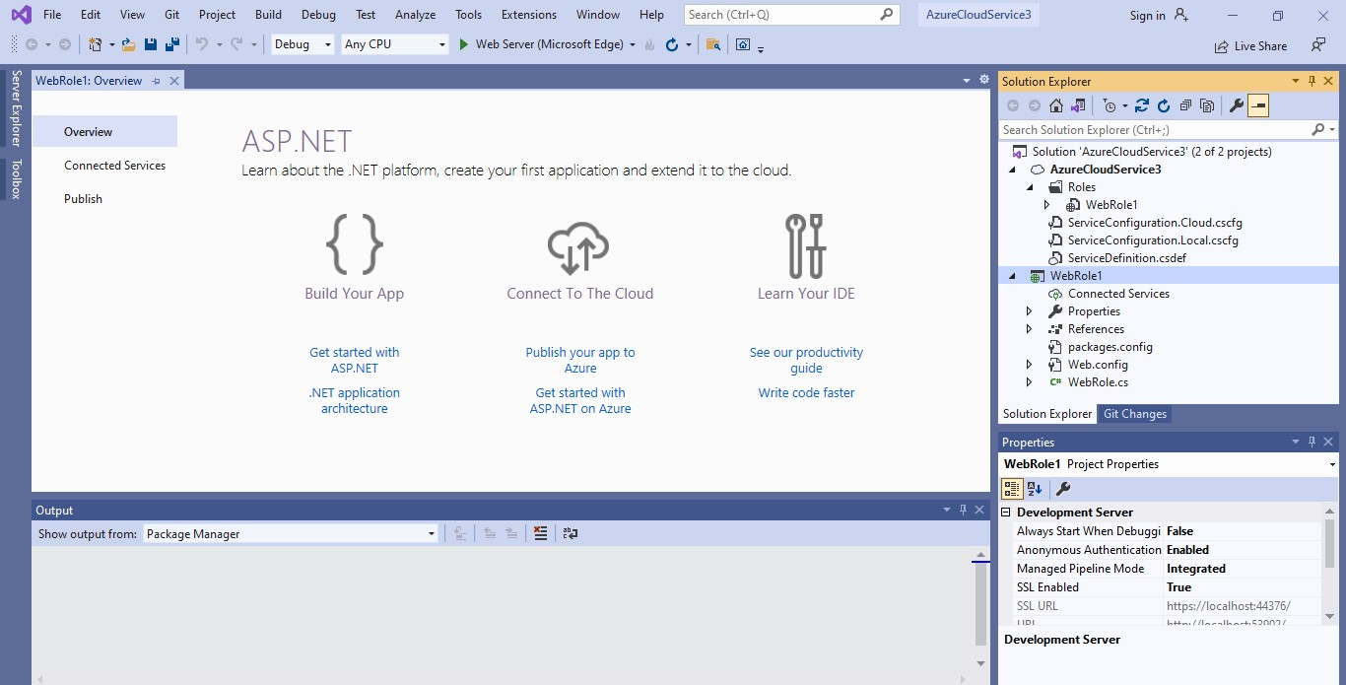

Then click on **Add Button 🡪 Select Web Form**

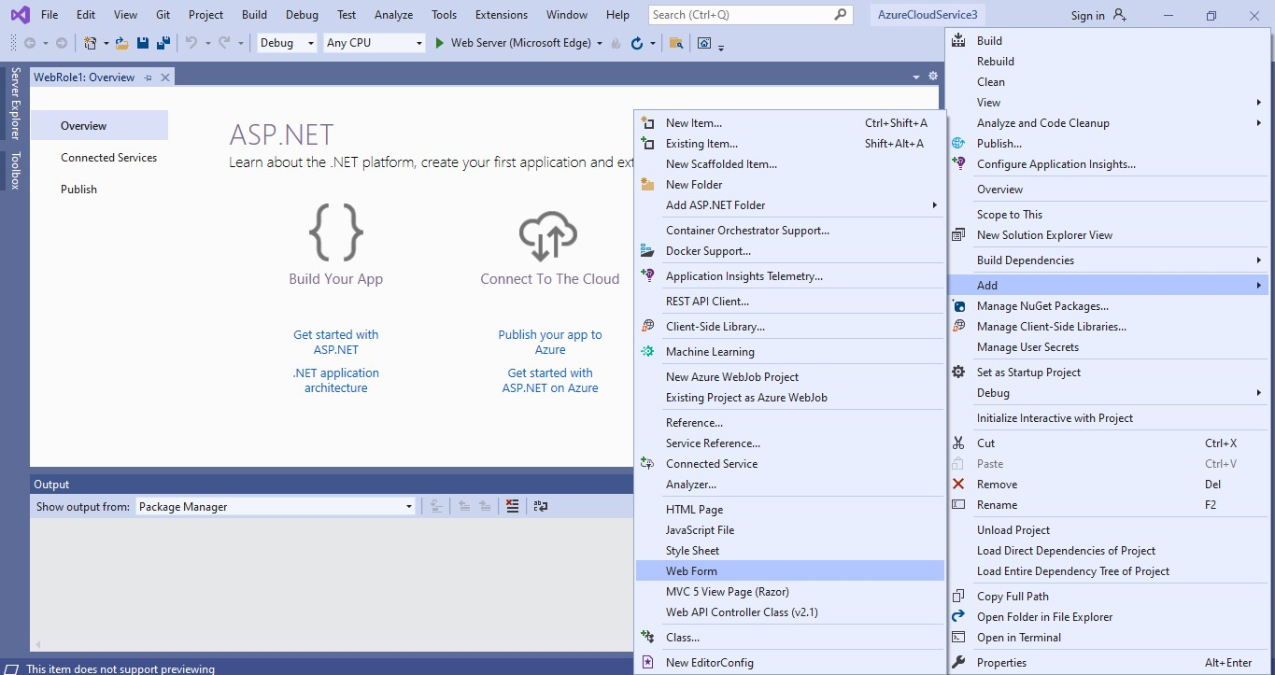

Give Name to Web Form

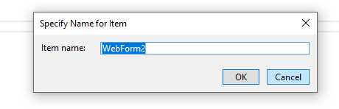

Click on OK Button. Below window will appear.

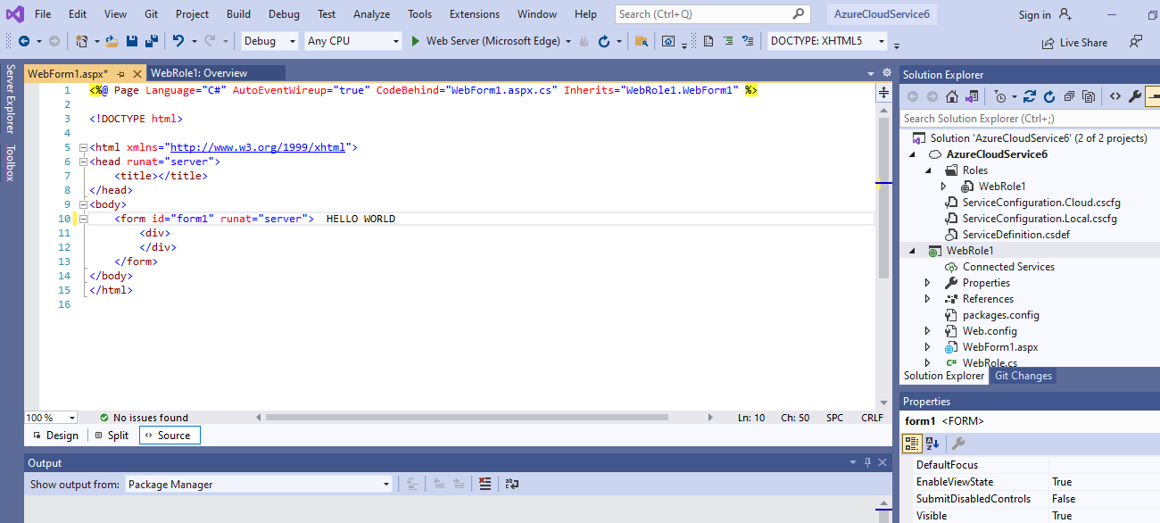

Then click on Execute Project.

Following is the output:

